**Theory section**

**Introduction**

**Ib** - Design current

**In** - Protective size

**Iz** - current-carrying capacity (with all corrections)

**It** - current-carrying capacity.

Zs  = Ze + (R1 + R2)

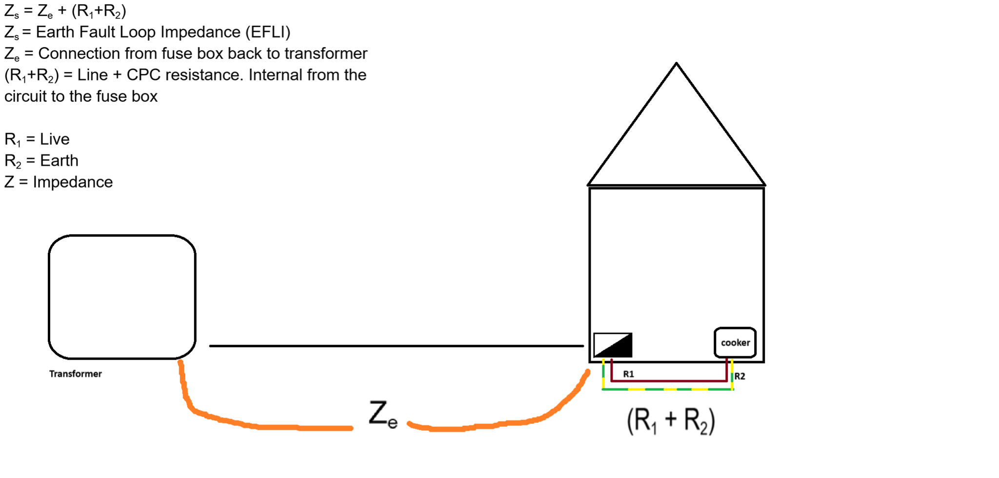

**Question:**

A 230 V 4kW load is to be wired in non-armoured single-core 70°C thermoplastic insulated copper conductors wired in steel conduit installed on the surface some 25 metres from the distribution board. **Three other similar circuits are installed in the same conduit which passes through an** area where the ambient temperature reaches 40°C. Calculate the cross-sectional area of cable required if protection is by a BS288-2 fuse. Show all working.

**Working out:**

**Voltage (V)** - informs us what kind of circuit or power supply is needed

**Kilowatts (kW)** - informs us of how much power is consumed or required

*(Used ChatGPT to get these definitions)*

1. **Ib -> design current**

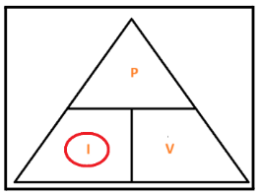

I = P/V

4,000/230 = 17.39 A

We do not calculate the diversity rule because the full load is not specified.

I**b = 17.39 A**

**2) In -> Protective device**

**In = 20 A**

**3) It - Current carrying capacity**

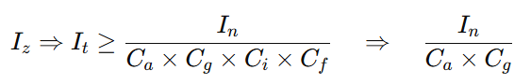

**Ca**=> Ambient temperature.

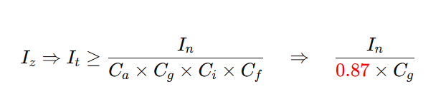

The ambient temperature is defined as the air temperature surrounding a particular object or area. The question states that “the ambient temperature reaches 40 °C”. The questions also states “thermoplastic 70°C insulated copper conductors”

|  | **Insulation** | | | | | |
| --- | --- | --- | --- | --- | --- | --- |
|  |  |  | **Mineral** | | | |
| **Ambient temperature** | **70°C thermoplastic** | **90°C thermosetting** | **Thermoplastic covered or bare and exposed to touch 70°C thermoplastic** | **cBare and not exposed to touch 105 °C** | | |
| **25** | **1.03** | **1.02** | **1.07** | **1.04** | | |
| **30** | **1.00** | **1.00** | **1.00** | **1.00** | | |
| **35** | **0.94** | **0.96** | **0.93** | **0.96** | | |
| **40** | **0.87** | **0.91** | **0.85** | **0.92** | | |

**Table F1 Page 168**

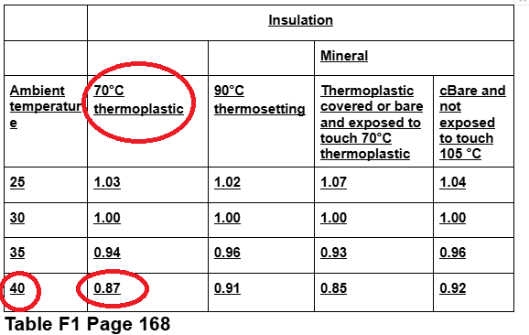

Therefore, using the table the answer for Ca is 0.87.

**Cg** => grouping

**“Three other similar circuits are installed in the same conduit …”**

| **Number of circuits or multi-core cables** | | | | | | | | | | | |
| --- | --- | --- | --- | --- | --- | --- | --- | --- | --- | --- | --- |
| **Arrangement (cable touching)** | **1** | **2** | **3** | **4** | **5** | **6** | **7** | **8** | **9** | **12** | **Applicable reference method for current-carrying capacities** |
| Bunched in air, on a surface, embedded or enclosed | 1.0 | 0.80 | 0.70 | 0.65 | 0.60 | 0.57 | 0.54 | 0.52 | 0.50 | 0.45 | A to F |
| Single layer on wall or floor | 1.0 | 0.85 | 0.79 | 0.75 | 0.73 | 0.72 | 0.72 | 0.71 | 0.70 | 0.7 | C |
| Single layer multicore on a perforated horizontal or vertical cable tray system | 1.0 | 0.88 | 0.82 | 0.77 | 0.75 | 0.73 | 0.73 | 0.72 | 0.72 | 0.72 | E |
| Single layer multicore on a cable ladder system or cleats etc | 1.0 | 0.87 | 0.82 | 0.80 | 0.80 | 0.79 | 0.79 | 0.78 | 0.78 | 0.78 | E |

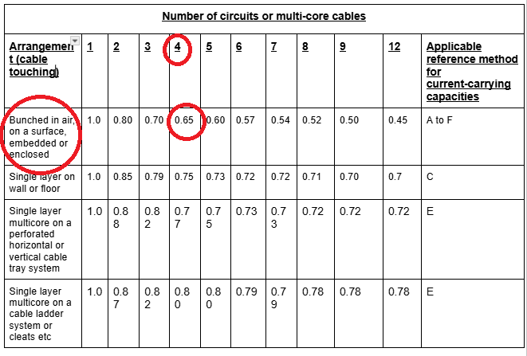

**It  = 37.37 A (Current carrying capacity without corrections)**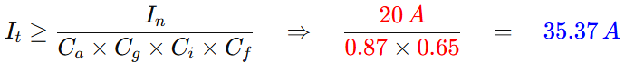

When you see the voltages 230V or 400v just remember:

* 230V - single phase systems
* 400V - three phase systems.

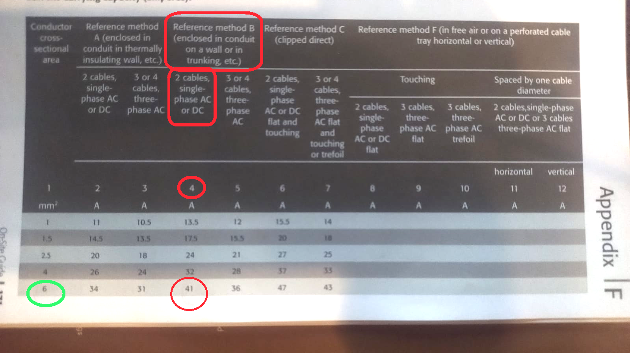

**Table F4(i) - page 171**

We used the above table to deduce the **Iz** value.

Remember that we deduced **It** to be **35.37 A**.

If we round this up, 41 is the next number (circled in red above)

The question states **230V** - which means it is a **single phase system**

The question states “enclosed into the same conduit” “..installed onto the surface”.

The answer highlighted in **green**, shows that we need a **6mm2** cable size. **6mm2** cable corresponds to a **41 A** which is enough.

**Iz = 6 mm2**

**Voltage drop**

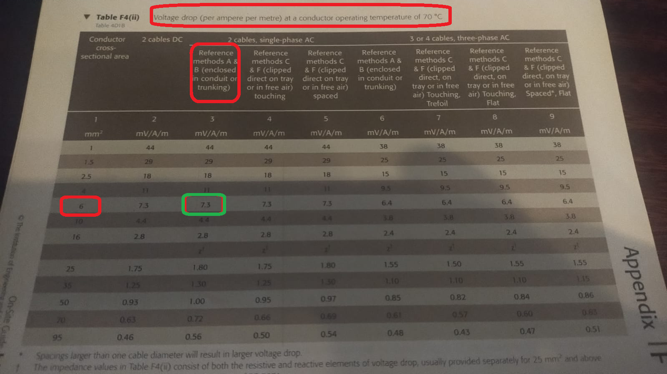

Table F4(ii) page 173

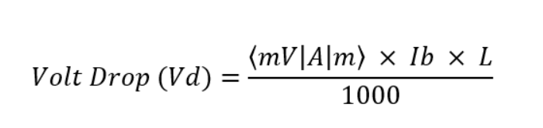

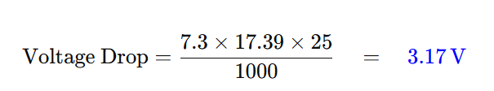

**Practical section**

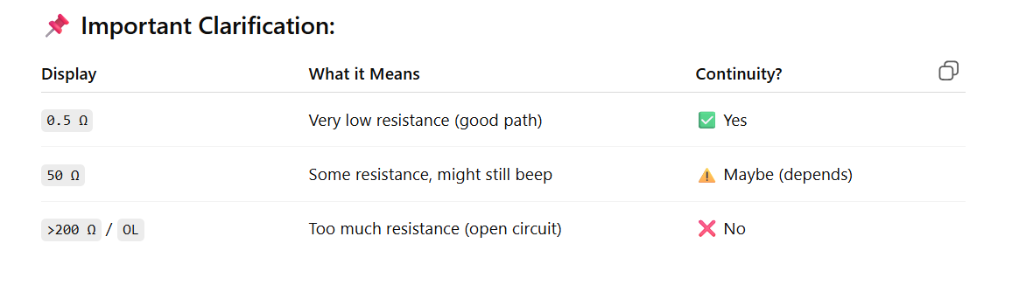

In the board below we also installed a radial circuit - which is highlighted in green.

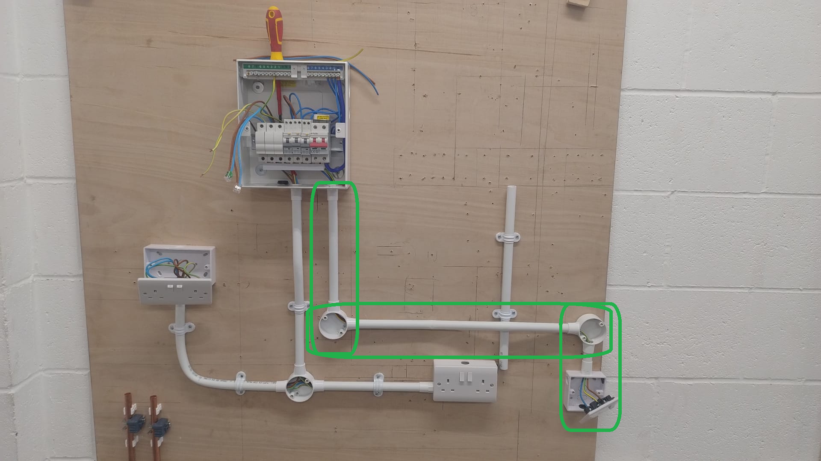

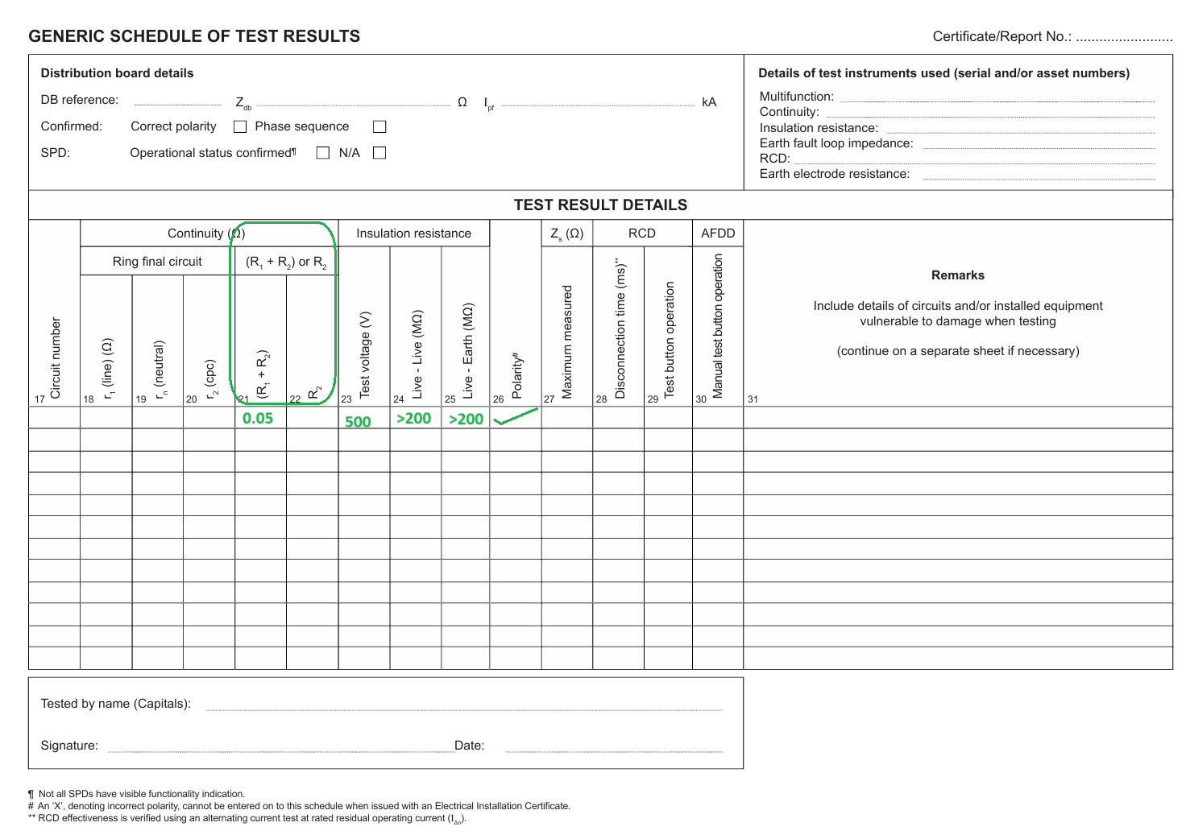

**Test for a Radial circuit**

**Step One - test for Continuity (Ω)**

**(R1 + R2)**

**R1 = Live** and **R2 = Earth**

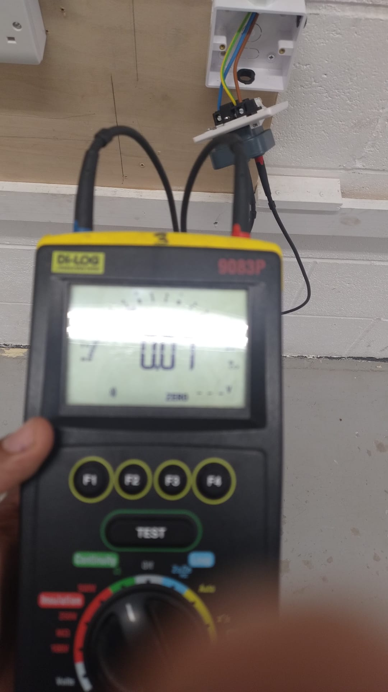

1. **Set-up electrical tester for continuity test:**

* Set the dial on the electrical tester to the “**continuity**” setting;
* Plug the tester socket into the plug;
* Attach the probes into the **Live** and **Earth** socket pins.

1. **In terms of the Fuse board:**

* Put the Earth wire into position two of the connector block;
* This is because the circuit that we wish to test is on the second RCD;
* The live wire can go anywhere in the connector block.

As a result of following **part A** and **part B** we create a loop in the circuit. A loop in which the electrical current flows down the **brown live wire** and back through the **green and yellow earth wire**.

**C) Hit the test button on the electrical tester - interpret the result:**

* First reading was **0.05 Ω (Ohms)**
* Second reading of **0.07 Ω (Ohms).**
* This means that there is very little resistance in the circuit.
* When there is little resistance this means there is a good flow of current.
* Continuity checks if there is a connection between two points.

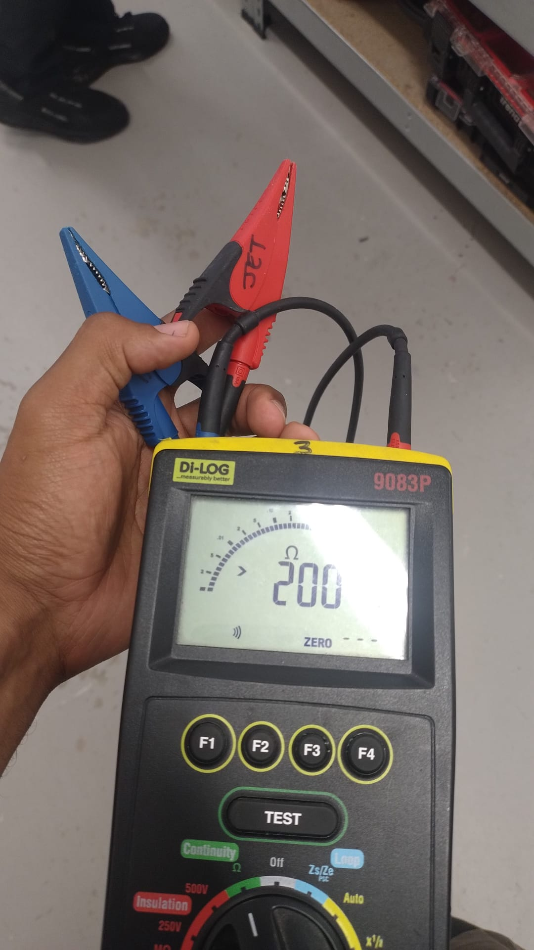

**>200 Ω or there around** - means no continuity or an open circuit. Resistance is too high to even measure.

**Insulation resistance**

**Step Two - Test voltage (V)**

Set the test voltage to 500 on the machine.

Write 500 on the test sheet because this is the voltage level.

**Step Three - Live - Live (MΩ)**

Means we test the **brown live wire** and the **blue neutral wire**.

We scored > 200Ω Ohms.

This test means that the **brown live wire** and the **blue neutral wire** do not touch each other in the radial circuit.

Does this score mean that because there is so much resistance the wires (**brown live wire** and the **blue neutral wire**) simply cannot be touching. Because if they were touching the resistance would be lower as there would be more current flow.

**Step four - Live - Earth (MΩ)**

Test the brown live wire and the earth wire. We got **>200 Ω (Ohms)** which means the wires are not touching.

**Step five - Polarity is ticked because we got a reading in Part One subsection D.**